# LuckMaster 3000 – Development Task

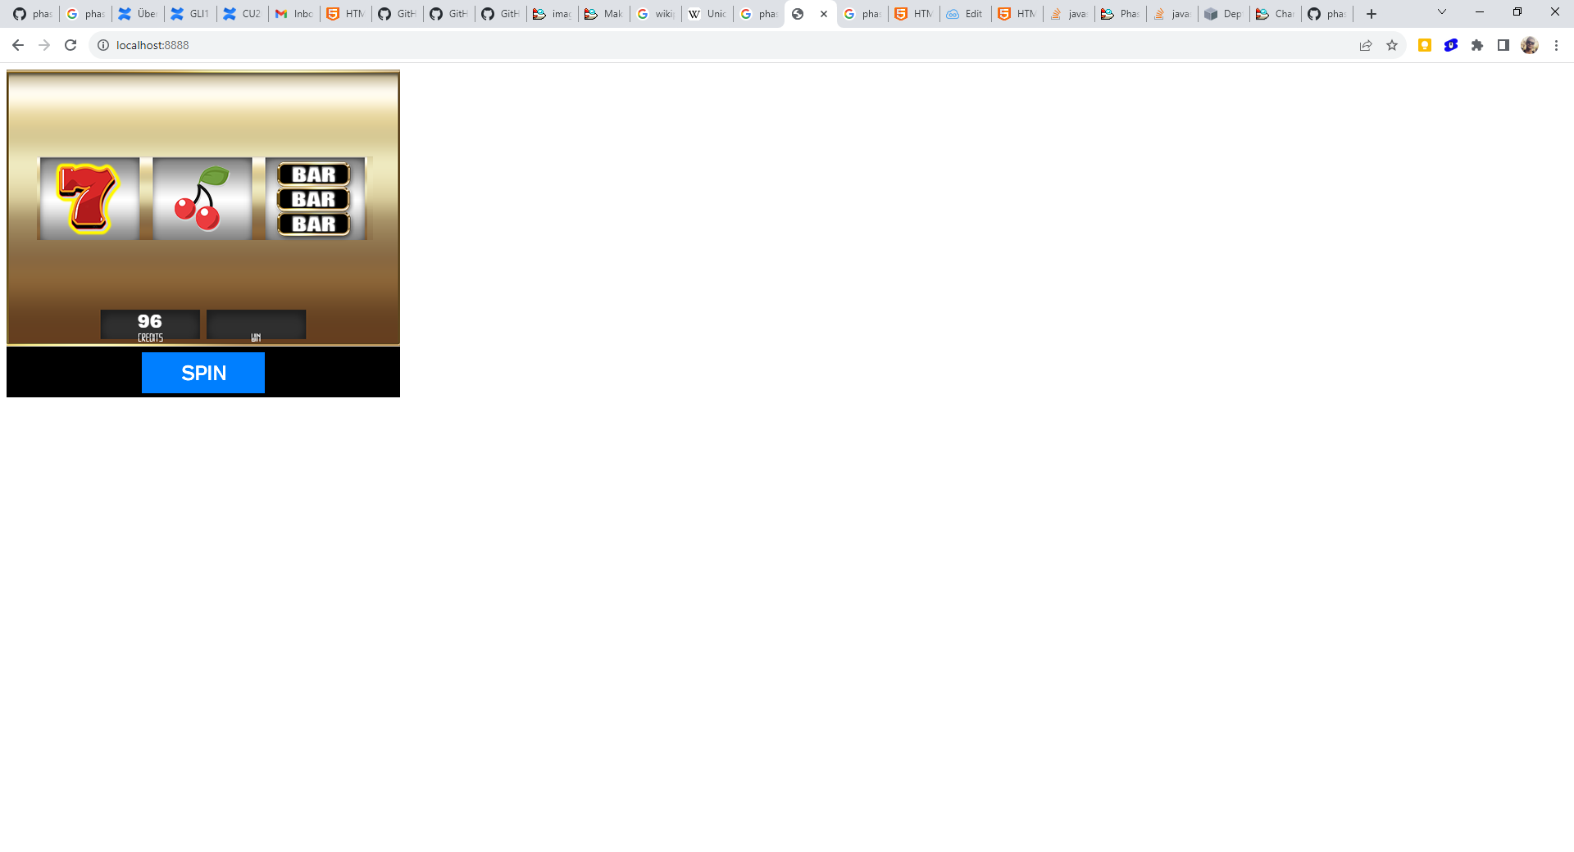

In the attached zip file you will find a functioning slot machine written with PHASER 2.7.

The game designer has made a few last minute decisions, which you should add now.

The following changes have to be made:

* Add the new reelstrip
  + The new reelstrip is longer than the old one, and includes a new symbol
  + All symbols should still pay the same amount
  + The “WILD” symbol should pay 50 credits if 3 of them land
  + The “WILD” symbol can substitute for any symbol, so for example   
    BELL-BELL-WILD should pay 5 credits, since WILD will behave like a bell
* Add a vertical blur to the symbols while (and only while) they are in the state SPIN (not final spin)
  + Only vertical (Y) blur,
  + Blur value: 20
* Add a tween to the spin start, where the symbols first move in the “wrong” direction
  + 30px against the correct direction
  + Duration: 500ms
  + Cubic.InOut